THESIS TITLE - ALL CAPS PERMITTED

ANOTHER TITLE LINE - IF NEEDED

THESIS REPORT (PHASE-II)

Submitted in Partial Fulfillment of the Requirements for the award
of the Degree of
MASTER OF ENGINEERING
(Energy Engineering and Management)
Submitted by

YOUR NAME
(Reg. No. xxxxxxxxxxxxx)

Under the guidance of
Dr. YOUR GUIDE NAME
ASSOCIATE PROFESSOR
DEPARTMENT OF MECHANICAL ENGINEERING

DEPARTMENT OF MECHANICAL ENGINEERING

ANNAMALAI UNIVERSITY
ANNAMALAI NAGAR
MAY -2012
ANNAMALAI UNIVERSITY

DEPARTMENT OF MECHANICAL ENGINEERING

BONAFIDE CERTIFICATE

This is to certify that this Thesis titled “TITLE OF YOUR THESIS IN ALL CAPITAL LETTERS” is the bonafide record of the work done by YOUR NAME (Reg. No……………) in partial fulfillment of the requirement for the Degree of Master of Engineering in Energy Engineering and Management during the year 20…- 20…. Certified further, that to the best of my knowledge the work reported herein does not form part of any other thesis or dissertation on the basis of which a degree or award was conferred on an earlier occasion on this or any other candidate.

YOUR GUIDE NAME YOUR HOD NAME
Designation Head of the Department
Dept. of Mechanical Engineering Dept. of Mechanical Engineering
Project Guide

ACKNOWLEDGEMENTS

Start here or [Insert]/(File) here ...

ABSTRACT
Start here or [Insert]/(File) here ...

TABLE OF CONTENTS
Chapter 1 Introduction (this is a Heading 1 style) 3
1.1Replace with heading (this is a Heading 2 style) 3
Replace with heading (this is a Heading 3 style) 3
1.2 Replace with heading (this is another Heading 2 style) 3
Chapter 2 Literature Review (this is a Heading 1 style) 3
2.1 Replace with heading (this is a Heading 2 style) 3
Replace with heading (this is a Heading 3 style) 3
Chapter 3Relevant to your work 3
Chapter 4 Relevant to your work 3
Chapter 5 Relevant to your work 3
Chapter 6 Experimental Results 3
Chapter 7 Conclusion 3

References 3

LIST OF FIGURES
Figure 1-1. The Waterfall of Tranquility. 3
Figure 1-2. Another figure 3
Figure 1-3. Yet another figure. 3
Figure 2-1. A church in the woods. 3

LIST OF TABLES
Table 1-1. The Table of Tranquility. (Replace this with table caption above the table) 3
Table 2-1. Another table. 3
Table 2-2. Yet another table. 3

REPLACE WITH CHAPTER TITLE (THIS IS A HEADING 1 STYLE)
This text is in the type style called “Normal” and should be used for the body of your thesis. This thesis template is based on PSTT v1 r11.
When we look to the individuals of the same variety or sub-variety of our older cultivated plants and animals, one of the first points which strikes us, is, that they generally differ much more from each other, than do the individuals of any one species or variety in a state of nature. When we reflect on the vast diversity of the plants and animals which have been cultivated, and which have varied during all ages under the most different climates and treatment, I think we are driven to conclude that this greater variability is simply due to our domestic productions having been raised under conditions of life not so uniform as, and somewhat different from, those to which the parent-species have been exposed under nature.

Replace with heading (this is a Heading 2 style)
There is, also, I think, some probability in the view propounded by Andrew Knight, that this variability may be partly connected with excess of food. It seems pretty clear that organic beings must be exposed during several generations to the new conditions of life to cause any appreciable amount of variation; and that when the organisation has once begun to vary, it generally continues to vary for many generations. No case is on record of a variable being ceasing to be variable under cultivation. Our oldest cultivated plants, such as wheat, still often yield new varieties: our oldest domesticated animals are still capable of rapid improvement or modification.
It has been disputed at what period of time the causes of variability, whatever they may be, generally act; whether during the early or late period of development of the embryo, or at the instant of conception. Geoffroy St Hilaire's experiments show that unnatural treatment of the embryo causes monstrosities; and monstrosities cannot be separated by any clear line of distinction from mere variations.

Replace with heading (this is a Heading 3 style)
But I am strongly inclined to suspect that the most frequent cause of variability may be attributed to the male and female reproductive elements having been affected prior to the act of conception. Several reasons make me believe in this; but the chief one is the remarkable effect which confinement or cultivation has on the functions of the reproductive system; this system appearing to be far more susceptible than any other part of the organization, to the action of any change in the conditions of life.

Replace with heading (this is a Heading 4 style)
Nothing is more easy than to tame an animal, and few things more difficult than to get it to breed freely under confinement, even in the many cases when the male and female unite. How many animals there are which will not breed, though living long under not very close confinement in their native country!
This is the “long quote” type style, used for prose extracts, or extended quotes from another’s work. generally attributed to vitiated instincts; but how many cultivated plants display the utmost vigour, and yet rarely or never seed! In some few such cases it has been found out that very trifling changes, such as a little more or less water at some particular period of growth, will determine whether or not the plant sets a seed. I cannot here enter on the copious details which I have collected on this curious subject.
Many exotic plants have pollen utterly worthless, in the same exact condition as in the most sterile hybrids, as illustrated in Figure 1-1. When, on the one hand, we see domesticated animals and plants, though often weak and sickly, yet breeding quite freely under confinement; and when, on the other hand, we see individuals, though taken young from a state of nature, perfectly tamed, long-lived, and healthy (of which I could give numerous instances), yet having their reproductive system so seriously affected by unperceived causes as to fail in acting, we need not be surprised at this system, when it does act under confinement, acting not quite regularly, and producing offspring not perfectly like their parents or variable.
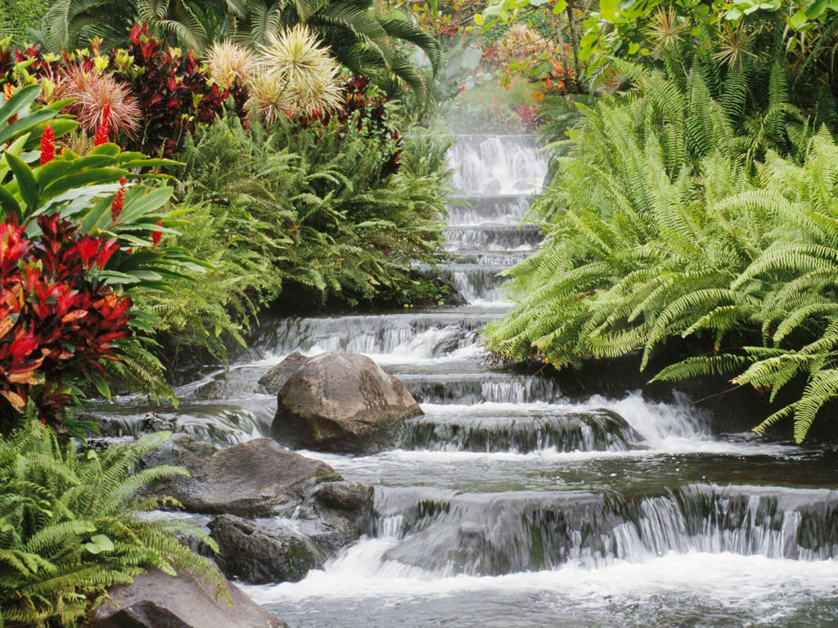
Fig 1.1 The Waterfall of Tranquility.

Copy and paste the figure and table placeholders as needed in your thesis. Paste or use Insert-->Picture-->From file to put figure in place of “Place Figure Here” text. For tables, use Word’s Table tools, or copy and paste a table from Excel.

Replace with heading (this is another Heading 2 style)
Sterility has been said to be the bane of horticulture; but on this view we owe variability to the same cause which produces sterility; a Figure 1-1 nd variability is the source of all the choicest productions of the garden. I may add, that as some organisms will breed most freely under the most unnatural conditions (for instance, the rabbit and ferret kept in hutches), showing that their reproductive system has not been thus affected; so will some animals and plants withstand domestication or cultivation, and vary very slightly perhaps hardly more than in a state of nature.

Fig 1.2 . Another figure

Each litter, sometimes differ considerably from each other, though both the young and the parents, as Muller has remarked, have apparently been exposed to exactly the same conditions of life; and this shows how unimportant the direct effects of the conditions of life are in

Fig 1.3 . Yet another figure.

Comparison with the laws of reproduction, and of growth, and of inheritance; for had the action of the conditions been direct, if any of the young had varied, all would probably have varied in the same manner.

Table 1.1 . The Table of Tranquility. (Replace this with table caption above the table)

165 | 1810 | 21
165 | 1974 | 22
165 | 2139 | 23
165 | 2303 | 24
165 | 2468 | 25
165 | 2632 | 26
165 | 2797 | 27
165 | 2961 | 28
165 | 3126 | 29
165 | 3290 | 30
165 | 3455 | 31
165 | 3619 | 1
165 | 3784 | 2

Habit also has a deciding influence, as in the period of flowering with plants when transported from one climate to another. In animals it has a more marked effect; for instance, I find in the domestic duck that the bones of the wing weigh less and the bones of the leg more, in proportion to the whole skeleton, than do the same bones in the wild-duck; and I presume that this change may be safely attributed to the domestic duck flying much less, and walking more, than its wild parent. The great and inherited development of the udders in cows and goats in countries where they are habitually milked, in comparison with the state of these organs in other countries, y conclude that very many of the most strongly-marked domestic varieties could not possibly live in a wild state. In many cases we do not know what the a

REPLACE WITH CHAPTER TITLE (THIS IS A HEADING 1 STYLE)
This text is in the type style called “Normal” and should be used for the body of your thesis. Great as the differences are between the breeds of pigeons, I am fully convinced that the common opinion of naturalists is correct, namely, that all have descended from the rock-pigeon (Columba livia), including under this term several geographical races or sub-species, which differ from each other in the most trifling respects.

Replace with heading (this is a Heading 2 style)
As several of the reasons which have led me to this belief are in some degree applicable in other cases, I will here briefly give them. If the several breeds are not var the present domestic breeds by the crossing of any lesser number: how, for instance, could a pouter be produced by crossing two breeds unless one of the parent-stocks possessed the characteristic enormous crop?

Figure 0-1. A church in the woods.
The supposed aboriginal stocks must all have been rock-pigeons, that is, not breeding or willingly perching on trees. But besides C. livia, with its geographical sub-species, only two or three other species of rock-pigeons are known; and these have not any of the characters of the domestic breeds.

Replace with heading (this is a Heading 3 style)
Hence the supposed aboriginal stocks must either still exist in the countries where they were originally domesticated, and yet be unknown to ornithologists; and this, considering their size, habits, and remarkable characters, seems very improbable; or they must have become extinct in the wild state. But birds breeding on precipices, and good fliers, are unlikely to be exterminated; and the common rock-pigeon, which has the same habits with the domestic breeds, has not been exterminated even on several of the smaller British islets.
Hence the supposed extermination of so many species having similar habits with the rock-pigeon seems to me a very rash assumption. Moreover, the several above-named become wild or feral, though the dovecot-pigeon, which is the rock-pigeon in a very slightly altered state, has become feral in several places.

Table 0-1. Another table.
11/09/09 | 11/16/09 | 11/23/09 | 11/30/09 | 12/07/09
18 | 15 | 7 | 14 | 16
16 | 13 | 5 | 18 | 20
34 | 28 | 12 | 32 | 36
33 | 28 | 11 | 32 | 34

An argument, as it seems to me, of great weight, and applicable in several other cases, is, that the above-specified breeds, though agreeing generally in constitution, habits, voice, colouring, and in most parts of their structure, with the wild rock-pigeon, yet are certainly highly abnormal in other parts of their structure: we may look in vain throughout the whole great family of Columbidae for a beak like that of the English carrier, or that of the short-faced tumbler, or barb; for reversed feathers like those of the jacobin; for a crop like that of the pouter; for tail-feathers

Table 0-2. Yet another table.
11/09/09 | 11/16/09 | 11/23/09 | 11/30/09 | 12/07/09
18 | 15 | 7 | 14 | 16
16 | 13 | 5 | 18 | 20
34 | 28 | 12 | 32 | 36
33 | 28 | 11 | 32 | 34

like those of the fantail. Hence it must be assumed not only that half-civilized man succeeded in thoroughly domesticating several species, but that he intentionally or by chance picked out extraordinarily abnormal species; and further, that these very species have since all become extinct or unknown. So many strange contingencies seem to me improbable in the highest degree.
Some facts in regard to the colouring of pigeons well deserve consideration. The rock-pigeon is of a slaty-blue, and has a white rump (the Indian sub-species, C. intermedia of Strickland, having it bluish); the tail has a terminal dark bar, with the bases of the outer feathers externally edged with white; the wings have two black bars: some semi-domestic breeds and some apparently truly wild breeds have, besides the two black bars, the wings chequered with black. These several marks do not occur together in any other species of the whole family. Now, in every one of the domestic breeds, taking thoroughly well-bred birds, all the above marks, even to the white edging of

REPLACE WITH CHAPTER TITLE
Some facts in regard to the colouring of pigeons well deserve consideration. The rock-pigeon is of a slaty-blue, and has a white rump (the Indian sub-species, C. intermedia of Strickland, having it bluish); the tail has a terminal dark bar, with the bases of the outer feathers

REPLACE WITH CHAPTER TITLE
Some facts in regard to the colouring of pigeons well deserve consideration. The rock-pigeon is of a slaty-blue, and has a white rump (the Indian sub-species, C. intermedia of Strickland, having it bluish); the tail has a terminal dark bar, with the bases of the outer feathers

REPLACE WITH CHAPTER TITLE
Some facts in regard to the colouring of pigeons well deserve consideration. The rock-pigeon is of a slaty-blue, and has a white rump (the Indian sub-species, C. intermedia of Strickland, having it bluish); the tail has a terminal dark bar, with the bases of the outer feathers

REPLACE WITH CHAPTER TITLE
Some facts in regard to the colouring of pigeons well deserve consideration. The rock-pigeon is of a slaty-blue, and has a white rump (the Indian sub-species, C. intermedia of Strickland, having it bluish); the tail has a terminal dark bar, with the bases of the outer feathers

Appendix A
REPLACE WITH APPENDIX TITLE
Some facts in regard to the colouring of pigeons well deserve consideration. The rock-pigeon is of a slaty-blue, and has a white rump (the Indian sub-species, C. intermedia of Strickland, having it bluish); the tail has a terminal dark bar, with the bases of the outer feathers
Bibliography

Start here or [Insert]/(File) here ...

